Arab Open University

Lebanon Branch



Faculty of Computer Studies

Data Science Program

TM471: Graduation Project

***Water Scarcity in the Arab world***

**Name:** Rony Al Moussa

**Id:** 220339

**Supervisor:** Dr. Maya Dawood

05/ 2024

Abstract

The availability of clean water nowadays has become a major concern in the world because of many factors. Speaking of which, the climate change and the unclean water is contributing to the fact that many scientists nowadays are predicting that there will be severe water shortage that will affect the entire world by 2040. Therefore, this problem is one of the fundamental problems that we have to solve in order to protect and prevent our most valuable and most important resource in the planet from being scarce, and to help maintaining our health, growing food, and managing the environment [1].

Acknowledgments

As an acknowledgment, I would like to thank my tutor ‘Dr. maya Daoud” for her guidance and encouragement provided throughout the period of the course. Her patience and valuable time have eased the process of making my research work in a more coordinated manner. On top of that, I would like to thank my family and friends for their support. Moreover, without that support, I couldn’t have succeeded in completing this research work in this academic year.

**Table Of Contents**

I. Introduction 7

1.1. Abstract 7

1.2. Problem 7

1.3. Solution 7

1.4. Aim and Scope 7

1.5. Actuality 8

1.6. Approaches and methods used 8

1.7. Selected software life-cycle 8

1.8. Schedule 9

II. Literature review 10

2.1. Introduction 10

2.2. mWater 10

2.3. Akvo Flow 11

2.4. Open Water Data 12

2.5. Comparative Table 13

2.6. Solution 14

III. Diagrams 15

3.1. ETL pipeline architecture 15

3.2. Merging datasets 16

3.3. Proposed system’s architecture 16

3.4. Data-logical model 18

3.4.1. Entities 18

3.4.2. Relationships 19

3.4.3. ER diagram 19

IV. Discovered datasets 20

4.1. Introduction 20

4.2. Interesting infographics and facts 20

4.2.1. The number of people without access to an improved water source 20

4.2.2. Share of the population without access to an improved water source 21

4.2.3. Number of deaths by risk factor in the Middle East & North Africa in 2019 22

4.2.4. Share of the population with access to safely managed drinking water 24

4.2.5. Death rate from unsafe water sources from 1990 to 2019 24

4.2.6. Share of deaths attributed to unsafe water sources from 1990 to 2019 25

4.2.7. Number of people without access to safe drinking water 26

4.3. The main dataset 27

4.4. Other datasets 28

V. Implementation 30

5.1. System’s requirements 30

5.1.1. Minimum Hardware Requirements: 30

5.1.2. Software Requirements: 30

5.2. Code of merging datasets 30

5.3. Selected tools for developing our water-scarcity risk evaluation system 31

5.4. Code of water-scarcity risk evaluation system 32

5.5. Conclusion 36

VI. References 37

**Table Of Figures**

Figure 1: mwater -number of users 11

Figure 2: importance of water on several sectors 12

Figure 3: total rainfall in India 13

Figure 4: ETL pipeline architecture 15

Figure 5: Merging Datasets 16

Figure 6: UML Component Diagram For our Proposed System's Architecture 18

Figure 7: Data-logical model (ER diagram) 19

Figure 8: Number of People Without Access to An Improved Water Source 21

Figure 9: Share of The Population Without Access to An Improved Water Source 22

Figure 10: Number of Deaths by Risk Factor in The World in 2019 23

Figure 11: Number of Deaths by Risk Factor in The Middle East and North Africa in 2019 23

Figure 12: Share of The Population with Access to Safely Managed Drinking Water 24

Figure 13: Death Rate from Unsafe Water Sources From 1990 to 2019 25

Figure 14: Share of Deaths Attributed to Unsafe Water Sources From 1990 to 2019 26

Figure 15: Number of People Without Access to Safe Drinking Water 27

Figure 16: Current water availability by country 34

Figure 17: Future Projection of water availability in the Arab World (National) 34

Figure 18: Future Projection of Water Availability in The Arab World (Rural) 34

Figure 19: Future Projection of Water Availability in the Arab World (Urban) 35

Figure 20: Future Projection of Sanitation Availability in the Arab World (National) 35

Figure 21: Future Projection of Basic Hygiene Services in the Arab World (National) 35

Figure 22: Future Projection of Basic Water Services in Schools in the Arab World (National) 36

Figure 23: Availability of Surface Water by Country 36

# I. Introduction

## 1.1. Abstract

Several countries nowadays are worrying about the date when there will be no more accessible clean water in the world, and specially, in the Arab countries [2]. That’s why, using some modelling and automation techniques, we are planning to predict the date when there will be no more accessible clean water in every country in the Arab world. On top of that, we are planning to provide other important graphs and data regarding this topic, which could benefit the scientists in order to advance and look at reliable data to help their research. Besides that, several other techniques will be discussed later in our report.

## 1.2. Problem

As we discussed earlier in our report, the clean water crisis is a major concern for all of us in the Arab world, since it has severe consequences that will affect all of the humans in the future in a way or another. Besides that, according to the United Nations statistics, there are approximately a whopping 2 billion people that don’t have drinking water. Moreover, according to many estimations, this issue is likely to get worse in the future, and it is projected to have 5 billion people that will face water shortages by 2050. Besides that, this issue may affect not only the poor people, but it also can affect many other industries, such as the agriculture industry, the energy industry, the manufacturing industry, along with many others. That’s why, we need to solve this issue as soon as possible in order to prevent all of that from happening.

## 1.3. Solution

In order to solve the above problems, the best thing to start with is to analyze and present some accurate data regarding this topic in each and every country in the Arab world. That’s why, our solution is to acquire some accurate data from reliable sources from the internet, and to do some modelling and automation systems, that would have a huge role of removing dirty data, analyzing the data, and presenting the data in an easy way so that all the people could have a reliable way to look at accurate statistics that could help them in order to start their research on how to solve the clean water crisis that could happen in the future. Furthermore, the information must be continuously updated to match the high-quality services in this system.

That’s why, after finishing this project, the main stakeholders which are the scientists and the organizations are predicted to have a better way to communicate and to solve this crisis.

## 1.4. Aim and Scope

The main goal from our graduation project is to predict the date when there will be no more accessible clean water in the Arab countries and to help out the scientists and the main stakeholders to have a reliable way in order to solve this crisis. Moreover, as we all know, all the information in our database must be continuously updated in order to match the high-quality services in this system.

## 1.5. Actuality

The actuality of assessing water scarcity risk in the Arab world lies at the intersection of cutting-edge data analysis and technological advancements. Leveraging data-driven methodologies and programming, this project aims to provide a forward-looking perspective on water scarcity risks. By employing predictive modeling and scenario analysis, we seek to forecast potential trajectories of water availability and demand in the Arab region [3]. The integration of advanced technology allows for a more nuanced understanding of climate change impacts, population dynamics, and the effectiveness of potential mitigation strategies. Furthermore, the utilization of Geographic Information System (GIS) tools enables the visualization and spatial analysis of water-related variables, offering a comprehensive view of the geographical distribution of water scarcity risks [4]. The actuality of this assessment is rooted in its ability to harness the power of data, programming, and technological innovation to not only anticipate challenges but also to facilitate evidence-based decision-making for sustainable water resource management in the Arab world.

## 1.6. Approaches and methods used

In our system, we will tend to apply several techniques during the life cycle of this system’s development. The first technique is to identify the risks before beginning to implement the project, and after that, we have to monitor it during the implementation to get a high value [5]. Secondly, we are going to use the ‘iterative and incremental’ approach, which is going to facilitate the process of developing our system in case we’ve got any type of errors or if we want to check and edit something at a previous stage in our project [6]. Furthermore, we are going to split our project into several tasks according to the schedule that we will mention in the schedule’s section. These and other techniques, will be used in the implementation of our project in order to get a good product at the end of our research work.

## 1.7. Selected software life-cycle

Speaking about the main approaches that we can use in software engineering during the implementation part, there is the old waterfall approach, and there is the new iterative and incremental approach. However, as we have mentioned earlier, using the iterative and incremental approach is so much better than using the old waterfall approach which has a lot of disadvantages, such as not being able of returning back to a previous step if we feel the need to do so. Therefore, this problem could be solved easily by using the iterative approach, which allow us to return back to a previous part of our implementation if there is a mistake that we need to fix [7]. Speaking of which, there are five main parts/steps that are involved in every software development project, and these steps are: setting up our requirements, designing our system, implementing our system, integrating our system, and testing our system. Therefore, as an example, if we encountered any problem while testing our system which requires us to go back to fix something in the implementation part, we can do so by using this approach.

## 1.8. Schedule

In order for our project to be successful, we have drawn up a schedule to schedule what we will do during this part of our project, and to divide our tasks into several tasks in order to solve each of them separately [8]. Hence, we have come up with this table given below.

|  |  |
| --- | --- |
| **Weeks** | **Task** |
| Week 1 | **1.** Deciding about the project idea |
| Weeks 2, 3 | **1.** Identifying the problem  **2.** Identifying the solution  **3.** Making our schedule |
| Weeks 4, 5 | **1.** Finalizing the introduction’s section |
| Week 6, 7 | **1.** Searching for similar platforms  **2.** Finalizing the literature review’s section |
| Weeks 8, 9 | **1.** Drawing some diagrams  **2.** Finalizing the diagrams’ section |
| Weeks 10, 11 | **1.** Finalizing our report (part1)  **2.** Finalizing our PowerPoint presentation (part1) |
| Week 12 | **1.** Submitting our report (part1)  **2.** Submitting our PowerPoint presentation (part1) |
| Week 13 | **1.** Break |
| Week 14 | **1.** Writing our system requirements |
| Weeks 15, 16 | **1.** Discovering cool infographics and facts  **2.** Documenting these infographics |
| Weeks 17, 18 | **1.** Finalizing the first part of our code |
| Weeks 19, 20 | **1.** Finalizing the second part of our code |
| Weeks 21, 22 | **1.** Writing our references  **2.** Writing our appendix |
| Weks 23, 24 | **1.** Finalizing our report (part2)  **2.** Finalizing our PowerPoint presentation (part2) |
| Week 25 | **1.** Submitting our report (part2)  **2.** Submitting our PowerPoint presentation (part2) |

# II. Literature review

## 2.1. Introduction

In this section, we will show some previous applications and websites that are related to this topic (clean water shortage), and we will do a simple summary of them by describing what were their problems, and what they did to solve them. Beside from that, we will discuss also about their designs, how they work, their advantages and disadvantages, and their features [9]. Speaking of which, the main applications that we are going to talk about are ‘mWater’, ‘Akvo Flow’, and ‘Open Water data’.

## 2.2. mWater

MWater is a non-profit company that was established in 2010 for the purpose of resolving problems regarding the lack of clean water. Speaking of which, John Feighery and his wife developed mWater, which has a purpose of recording the precise clean water quality tests on any mobile device. Moreover, using this application, the users can view the data, add pictures, write notes, and add data from new tests. Aside from that, mWater has a lot of advantages, such as it is free and open to everybody, it supports the ability of collecting offline data, and it has built-in data analysis and visualization tools. Furthermore, it includes several features, such as it helps to collect the data using any phone or browser, and it helps with designing and managing surveys. Moreover, it helps with analyzing and visualizing the data related to the clean water, and it is very customizable [10]. However, on the other hand, it has a lot of disadvantages too, such as it is not easy to learn, and it has a limited scope especially regarding water quality monitoring and hydrological modelling.

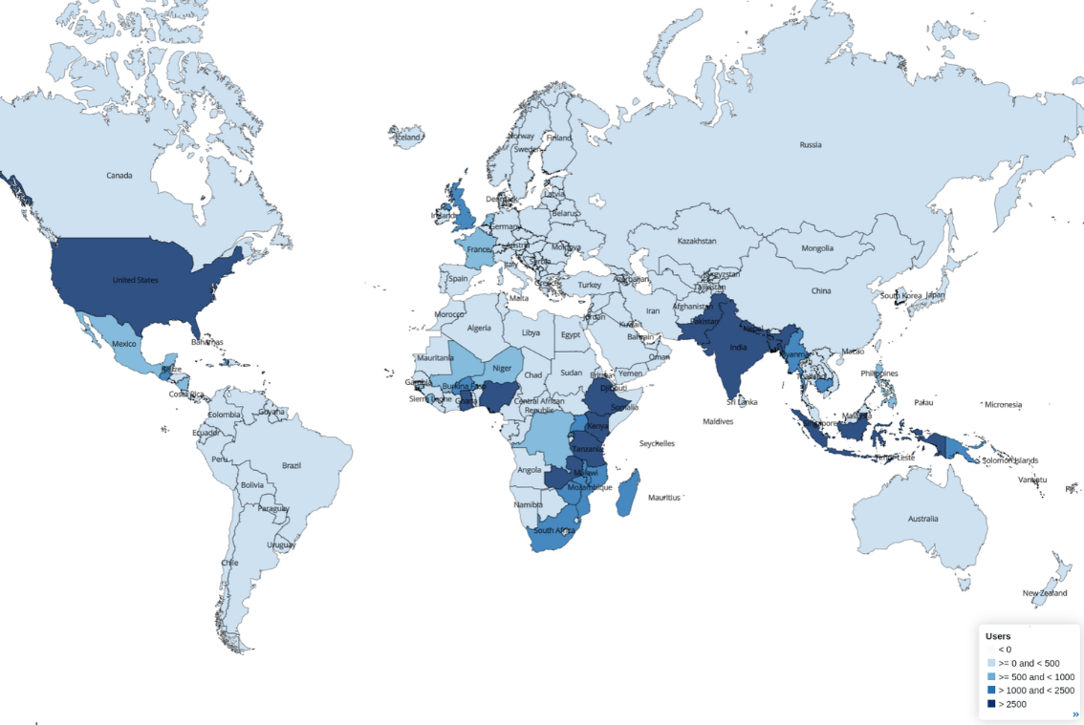

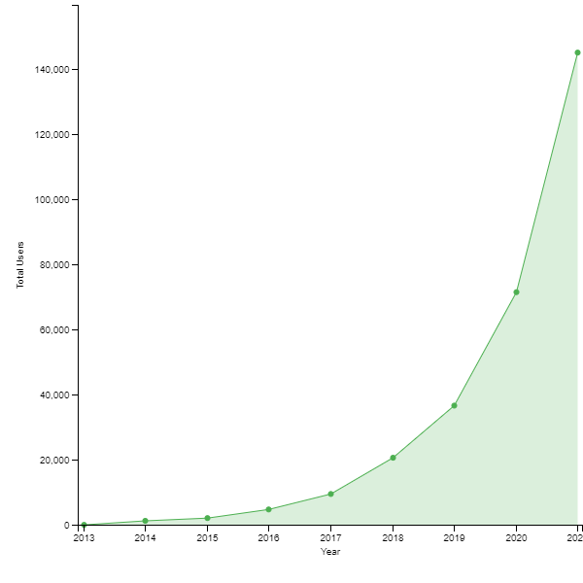

Figure : mwater -number of users

As we can see in Figure 1: mwater -number of users, there are a bunch of users who use ‘mWater’ from different parts in the world especially in the US, East Africa, and South East Asia. However, there are no users in a lot of other countries as well, especially in South America, Oceania, and in some parts of Europe. Furthermore, as we can see in the second photo, the number of users who are using mWater is constantly increasing [11].

## 2.3. Akvo Flow

Akvo Flow is also a non-profit organization that was established in 2008 by Peter van der Linde and Jeroen van der Sommen in Stockholm. Speaking of which, the main purpose of this application is to provide more accurate data about clean water. On top of that, by having reliable data, all the governments can benefit from that in order to solve the water shortage crisis that could happen in the future. Moreover, after 14 years of establishment, ‘Akvo Flow’ is now available in more than 70 countries across the globe. Aside from that, their main abstract is to ‘bring data-driven decision making and innovative technology to the development sector and contribute to a better world’ [12]. However, while talking about its advantages, it is necessary to mention that it is easy to collect data, it supports the ability of collecting offline data, and it has a real-time monitoring feature. Furthermore, it includes several other features, such as it has customizable forms, and facilitates quality control processes in order to ensure data reliability and accuracy. However, on the other hand, its disadvantages include that it is not easy to learn, and it has limited integrations with other databases and systems.

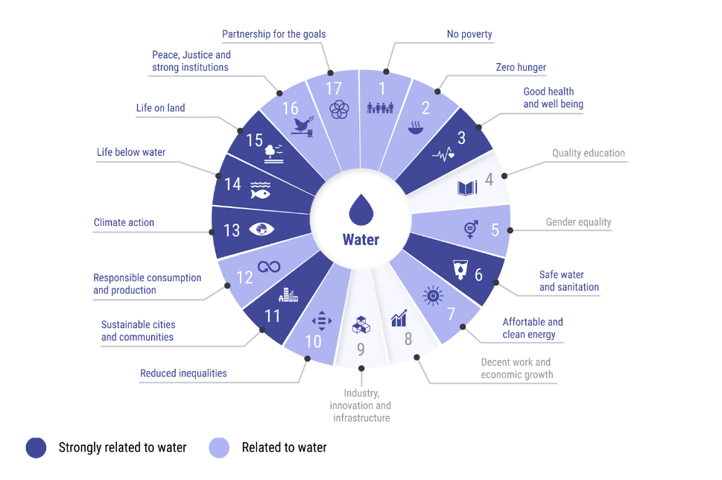

Figure : importance of water on several sectors

As we can see in Figure 2: importance of water on several sectors, this figure shows how much several sectors are related to water. Speaking of which, we can conclude that the darker the color, the more related the sector is to solve the water crisis [13].

## 2.4. Open Water Data

‘Open Water Data’ is also a non-profit organization that was established in 2017 by some software developers from Datameet. Speaking of which, this platform works only in India. Aside from that, its aim was to provide open water data for all of the Indians in order to help them and to help the government to access reliable data regarding clean water in India to solve the clean water crisis. That’s why, the main developers created a map where they show all the data related to this topic. Besides that, it main advantages is that it has comprehensive water data regarding clean water in India, it offers data analysis and visualization tools, and it assists in decision making process. Furthermore, it includes several features, such as it provides access to diverse datasets, and it has some integrations opportunities with other applications and systems. However, on the other hand, its main disadvantage is that it is only available in India, and it is not easy to use.

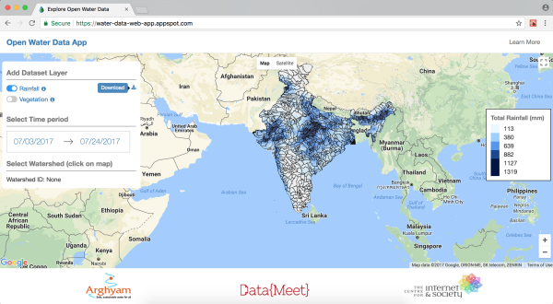

Figure : total rainfall in India

As we can see in Figure 3: total rainfall in India, this is a map of India which shows the total rainfall in each part of India [14].

## 2.5. Comparative Table

|  |  |  |  |  |
| --- | --- | --- | --- | --- |
| **Existing Solutions** | **Advantages** | | **Disadvantages** | **Features** |
| **mWater** | -Easy Data Collection -Available offline -Visualizations -Customizability | -Not easy to use -Limited Scope -Technical requirements -Scalability -Integration -Cost | | -Data collection -Visualizations -Real-time monitoring -Customizability -Mobile and Web Compatibility |
| **AkvoFlow** | -Easy Data collection -Available offline -Customizable forms -Real-time monitoring -Visualizations | -Limited integration -Not easy to use -Not available in all countries | | -Mobile support -Customizable forms -Offline data collection -Real-time monitoring -Visualizations |
| **Open Water Data** | -Comprehensive data -Visualizations -Decision support -Integration opportunities | -Data availability -Technical expertise | | -Diverse datasets -Visualizations -Decision support -Open-Data approach |

## 2.6. Solution

As we can see clearly, all of the above-mentioned platforms have lots of disadvantages that motivated us to do our project which will be available for each and every country in the Arab world. On top of that, we will be trying to have a system that doesn't have the disadvantages mentioned above, and we will make our system easy to use, free of charge, and scalable, such that it has to have enough integration with other databases and systems, and it must have diverse datasets, offline data collection, and real-time monitoring and visualizations.

# III. Diagrams

## 3.1. ETL pipeline architecture

In this section, we are going to represent our main ETL pipeline architecture which I created using draw.io. Speaking of which, the ETL pipeline architecture has to represent the three main steps of every ETL architecture, which consists of the extract part, the transform part, and the load part [15].

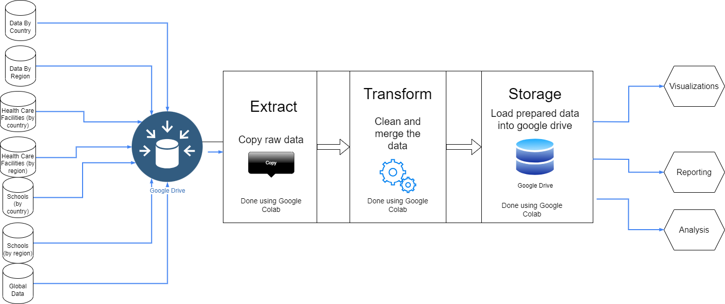

Figure 4: ETL pipeline architecture

As we can see in Figure 4: ETL pipeline architecture, firstly, we gathered our seven datasets (which we are going to talk more about in the report), and we imported them into Google Drive. After that, using Google Collab, we extracted these datasets from Google Drive using pandas and other frameworks. Then, we transformed our datasets by trying to figure out if there is any dirty data and we tried to handle the dirty data, and then, we merged our datasets as mentioned in the previous sections. Lastly, after doing all of these steps using python and Google collab, we loaded and stored our two big merged datasets into Google Drive. Besides that, after we loaded our merged datasets, we can use them to do further visualizations, reporting, and analyses.

## 3.2. Merging datasets

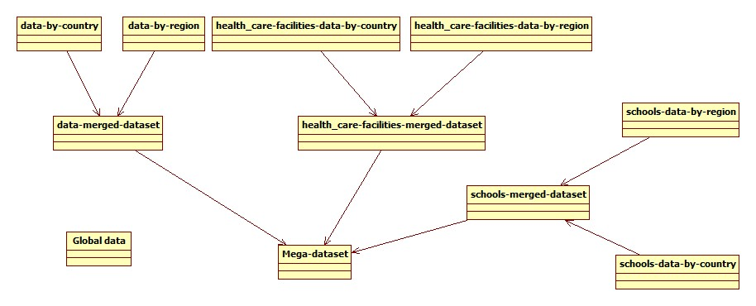

Figure 5: Merging Datasets

As we can see in Figure 5: Merging Datasets, this figure shows how our datasets are merged in google collab. Speaking of which, the global dataset is our main dataset and it contains everything related to the clean water in the Arab countries, and therefore, there is no need to merge it with other datasets. However, we decided to merge the data-by-country dataset and the data-by-region dataset into a dataset called “data-merged-dataset”, and the healthcare-facilities-data-by-country dataset and the healthcare-facilities-data-by-region dataset into a dataset called “healthcare-facilities-merged-dataset”, and the schools-data-by-country dataset and schools-data-by-region dataset into a dataset called “schools-merged-dataset”. After that, we decided to merge the data-merged dataset, the healthcare-facilities-merged dataset, and the schools-merged dataset into a mega dataset called “Mega-dataset”.

## 3.3. Proposed system’s architecture

The proposed system's architecture for the Water-Scarcity Risk Evaluation System is designed to seamlessly integrate data, analysis tools, and machine learning models within the Google Colab and Python environment [16]. The architecture follows a modular and scalable approach to accommodate the complexity of water-scarcity risk assessment in the Arab world. Key components of the proposed system's architecture include:

**1-Data Integration Layer:**

* **Objective:** This layer focuses on integrating datasets from Google Drive, ensuring the inclusion of historical data spanning variables crucial for water-scarcity risk assessment.
* **Implementation:** Utilizing Python libraries, such as Pandas and Google Colab-specific tools, to efficiently import, preprocess, and merge datasets for comprehensive analysis.

**2-Framework Integration Layer:**

* **Objective:** Facilitate seamless integration with major Python-based frameworks for AI and data science, specifically TensorFlow and Scikit-learn.
* **Implementation:** Leveraging the capabilities of Google Colab to effortlessly incorporate these frameworks, allowing for the implementation and evaluation of machine learning models.

**3-Machine Learning Model Layer:**

* **Objective:** Implement a hybrid model combining statistical regression models and machine learning ensemble techniques for robust water-scarcity risk prediction.
* **Implementation:** Utilizing TensorFlow and Scikit-learn functionalities within Google Colab to build, train, and evaluate the hybrid model with real data.

**4-Google Colab Cloud Computing Layer:**

* **Objective:** Harness the power of cloud-based computing resources provided by Google Colab for efficient model training and analysis.
* **Implementation:** Designing the system to seamlessly interact with Google Colab's cloud infrastructure, ensuring scalability and resource optimization.

**5-Visualization Layer:**

* **Objective:** Enable effective communication of model outcomes through visualization tools.
* **Implementation:** Leveraging Python libraries such as Matplotlib and Seaborn to create visualizations.

The proposed architecture emphasizes flexibility, scalability, and accessibility, aligning with the goal of providing a user-friendly platform for water-scarcity risk assessment. Through this modular structure, stakeholders, including policymakers and water resource managers, can navigate and leverage the system efficiently, fostering informed decision-making for sustainable water resource management in the Arab world.

However, in order to provide a visual representation of the system's components and interactions, we have included a UML component diagram shown below, which was created using ‘Whitestar UML’ software. This diagram complements the earlier textual description, offering a more intuitive understanding of the system's structure.

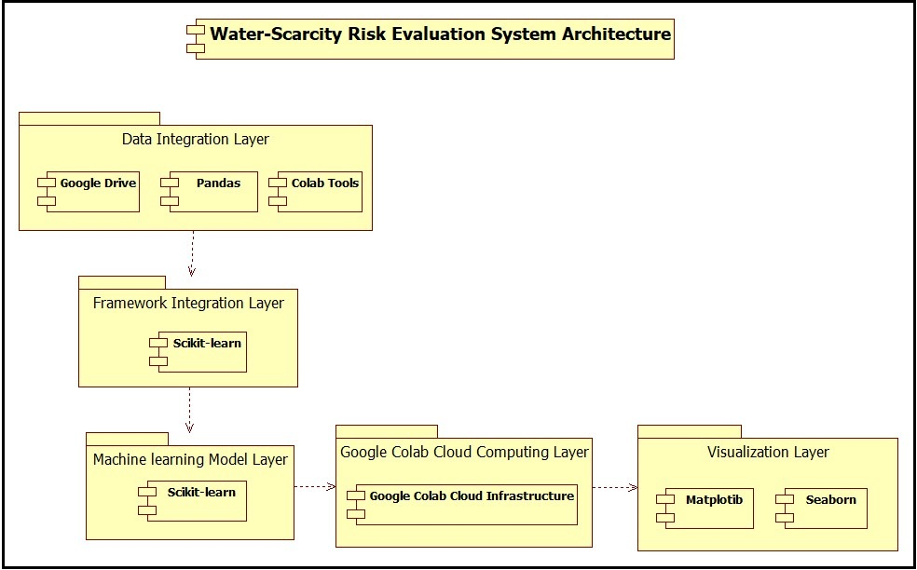

Figure 6: UML Component Diagram For our Proposed System's Architecture

## 3.4. Data-logical model

In the following section, we present the datalogical model for our Water-Scarcity Risk Evaluation System. A datalogical model serves as a fundamental representation of how data entities are structured within the system and how they interconnect. This model is crucial for understanding the underlying data architecture, relationships, and the logic behind our risk evaluation approach. The system's datalogical model encapsulates the essential components, their attributes, and the associations that form the backbone of our comprehensive approach to assessing water scarcity risk in the Arab world. The provided code snippet serves as a conceptual representation, outlining the relationships and attributes that define our data entities.

**Here is the code snippet:**

### 3.4.1. Entities

1. **Country:**

- Attributes: CountryID (Primary Key), Name, Region.

1. **WaterAvailability:**

- Attributes: WaterAvailabilityID (Primary Key), CountryID (Foreign Key), Year, NationalAvailability, RuralAvailability, UrbanAvailability.

1. **WaterScarcityRiskIndex:**

- Attributes: RiskIndexID (Primary Key), CountryID (Foreign Key), WaterAvailibilityID (Foreign Key), Year, RiskIndexValue.

### 3.4.2. Relationships

* One-to-Many relationship between **Country** and **WaterAvailability:**

One country can have multiple records in the WaterAvailability table for different years.

* One-to-One relationship between **WaterAvailability** and **WaterScarcityRiskIndex:**

One WaterAvailability record corresponds to one WaterScarcityRiskIndex record for the same country and year.

### 3.4.3. ER diagram

After representing the data-logical model using a code snippet, we will be representing it using an entity-relationship (ER) model, which is a fundamental representation that illustrates how data entities are organized and interconnected within our Water-Scarcity Risk Evaluation System [17]. Speaking of which, this ER diagram encapsulates essential components such as countries, water availability records, and the calculated water-scarcity risk index. Each entity's attributes and the relationships between them form the backbone of our comprehensive approach to assessing water scarcity risk in the Arab world. Therefore, we decided to draw the following ER diagram for our system:

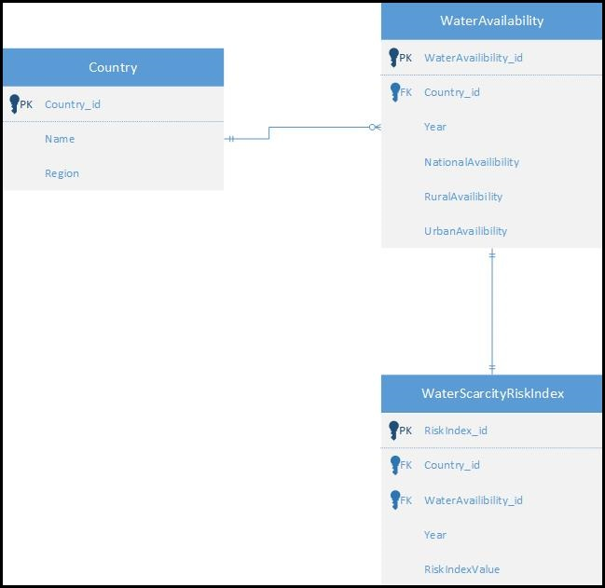

Figure 7: Data-logical model (ER diagram)

# IV. Discovered datasets

## 4.1. Introduction

After setting up our measurements by which we want to measure the availability of clean water in the Arab countries, we need to search for reliable datasets in order for us to analyze them and visualize the results accordingly in order to help us with our research work. Speaking of which, in order for the datasets to be reliable, we decided to make our research in four different websites, and these websites were created by UNICEF, GlobalWaters, OurWorldInData, and DataWorld, which are very reliable ways in order to collect our water data. Speaking of which, after entering their main websites, we tried to base our research to be only in the Arab countries, and compare it with the world average and the main improvements that happened regarding this topic in the past few decades. On top of that, not only did we collect valuable excel datasets, but we also collected some valuable diagrams that could help us to identify the main water issues in the Arab world.

## 4.2. Interesting infographics and facts

In the OurWorldInData website, we discovered a lot of cool infographics and facts about the access to clean water in the Arab countries [18]. On top of that, these cool facts are presented through several ways such as using some charts or tables which helped us to understand these facts in a better way. Speaking of which, we collected various charts that are related to our topic, and these charts represent the death rate from unsafe water sources from 1990 to 2019, the number of deaths by risk factor in 2019, the number of people without access to an improved water source, the number of people without access to safe drinking water, the share of death attributed to unsafe water resources from 1990 to 2019, the share of the population with access to safely managed drinking water, and the share of the population without access to an improved water source in the Arab countries.

### 4.2.1. The number of people without access to an improved water source

First of all, we would like to represent a chart that represents the number of people without access to an improved water source in the Arab countries from the yar 2000 to 2020, and see whether we are making some improvements regarding this topic or not.

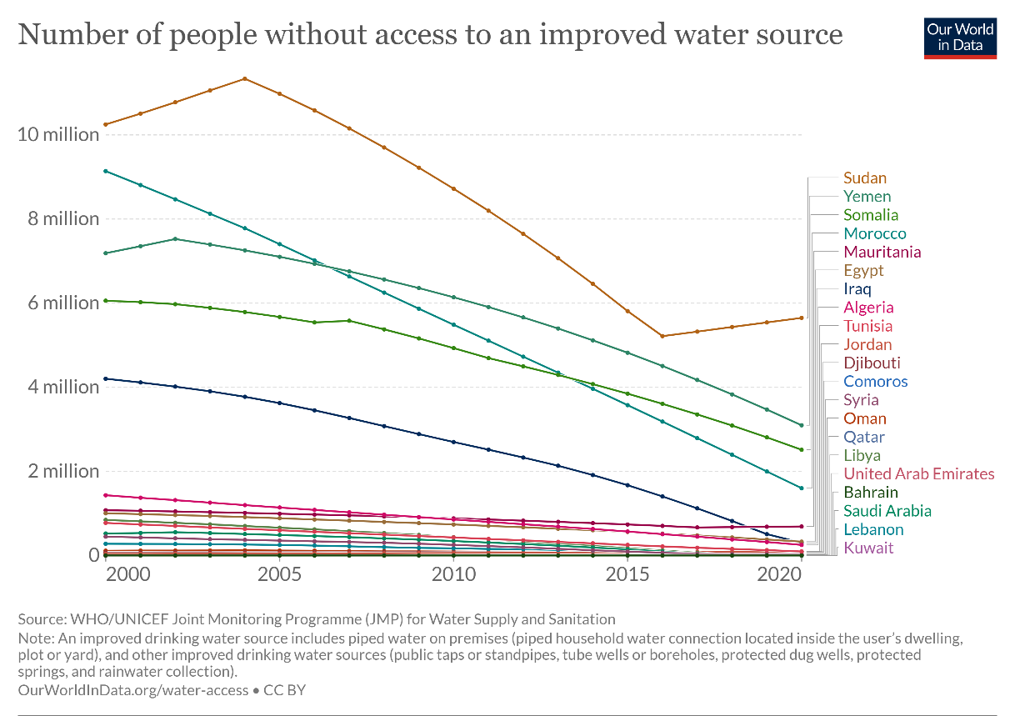

Figure : Number of People Without Access to An Improved Water Source

As we can see in Figure 1: Number of People Without Access to An Improved Water Source, this chart represents the number of people without access to an improved water source in the Arab countries. Speaking of which, there are several Arab countries that are doing better than others like Kuwait, Lebanon, and Saudi Arabia, which have less than 2 million people each who have no access to an improved water source, while others are doing very badly, such as Sudan, Yemen, and Somalia, which have over 4 million people each who have no access to an improved water source. However, there are several factors that may contribute to having bad results such as the population of the country, and the climate of that country that may affect our analysis badly. Speaking of which, it is not fair to compare Lebanon, which has a little over 5 million inhabitants and its climate is very mild, with Yemen, which has a little under 33 million inhabitants and its climate is less mild and drier. Nevertheless, apart from Sudan and Mauritania, we can see that most of the Arab countries are having some improvements regarding this issue in the past few decades, because the number of people without access to an improved water source has decreased over the years which is good in general, but there is always a room for more improvement.

### 4.2.2. Share of the population without access to an improved water source

Since we cannot really rely on the first analysis because the number of the population may vary from country to country, we decided to collect another chart from the same source, which has a role of showing the percentage of the population without access to an improved water source, which is considered to be more reliable since it shows the main percentage, regardless of the number of the population of the country.

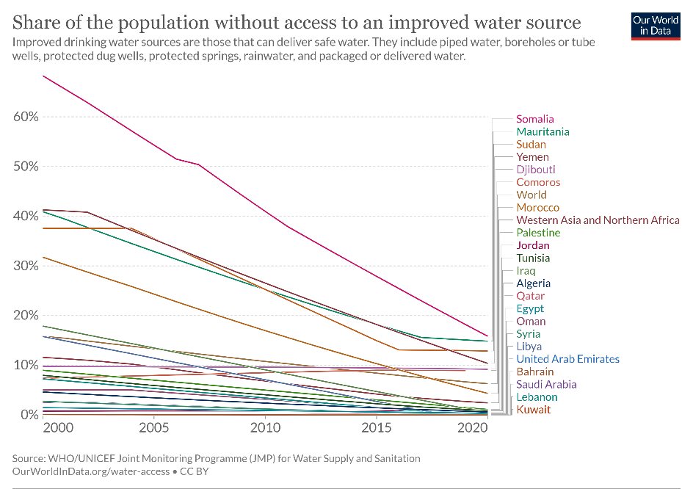

Figure : Share of The Population Without Access to An Improved Water Source

As we can see in Figure 2: Share of The Population Without Access to An Improved Water Source, this chart represents the percentage of people without access to an improved water source in the Arab countries. On top of that, we decided to represent also the average percentage of people without access to an improved water source in the world and in western Asia and northern Africa in order to compare the Arab countries with the world regarding this issue. Speaking of which, there are a lot of Arab countries that are doing better than the world average such as Kuwait, Lebanon, Saudi Arabia, along with many others that have a percentage of nearly 1% of the population that don’t have access to an improved water source. However, on the other hand, there are some Arab countries that are doing worse than the world average such as Somalia, Mauritania, Sudan, Yemen, Djibouti, and Comoros, that have a percentage above 9% of the population that don’t have access to an improved water source. However, as we can see, the percentage of the population without access to an improved water source in the Arab countries has decreased drastically over the past few decades, but there is always a room for more improvement.

### 4.2.3. Number of deaths by risk factor in the Middle East & North Africa in 2019

In this section, we are going to represent two figures that show the number of deaths by risk factor in 2019 in both the whole world and in the middle East & Northern Africa which generally speaking, apart from Iran and Turkey, represent the Arab countries.

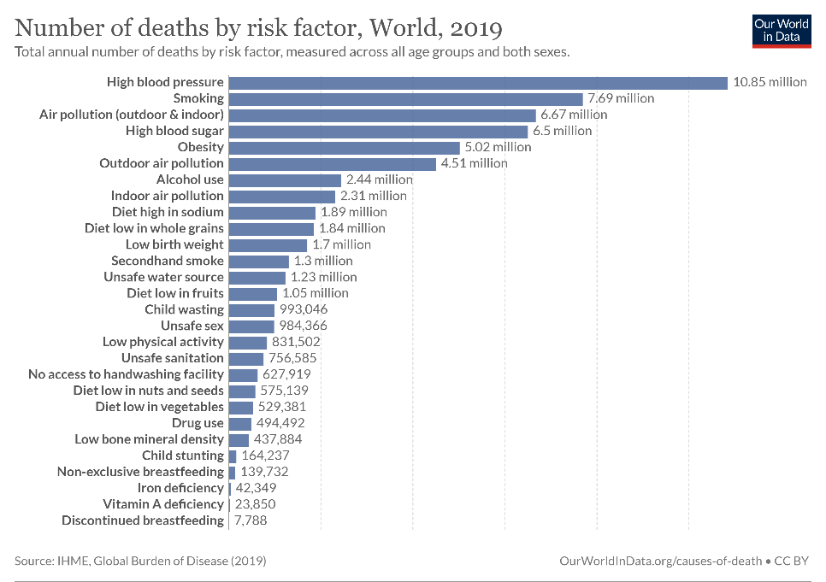

Figure : Number of Deaths by Risk Factor in The World in 2019

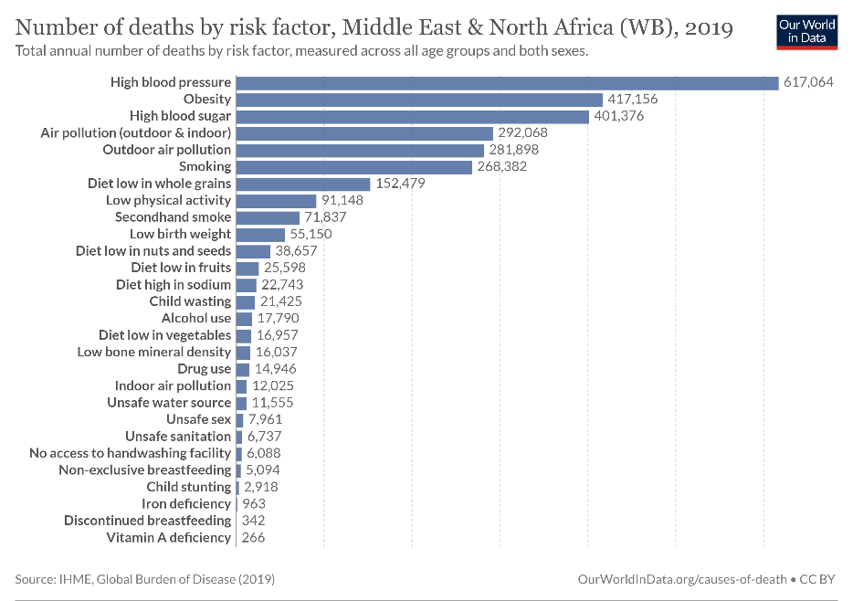

Figure : Number of Deaths by Risk Factor in The Middle East and North Africa in 2019

As we can see in Figure 3: Number of Deaths by Risk Factor in The World in 2019, unsafe water source, unsafe sanitation, and no access to handwashing facilities are positioned in the 13th, 18th, and 19th places respectively regarding the number of deaths by risk factor in the world, which are considered to be pretty high in general. However, on the other hand, and as we can see in Figure 4: Number of Deaths by Risk Factor in The Middle East and North Africa in 2019, unsafe water source, unsafe sanitation, and no access to handwashing facilities are positioned in the 20th, 22th, and 23th places respectively regarding the number of deaths by risk factor in the middle East & Northern Africa, which is considered better than the world in general. However, the middle east & Northern Africa is doing worse than the world in other factors, which are not our concerns in our research work.

## 4.2.4. Share of the population with access to safely managed drinking water

Another important factor to consider is the share of the population with access to safely managed drinking water in the Arab countries, because there may be a lot of people that have access to an available water source, but a lot of that water may be not safe to drink in general.

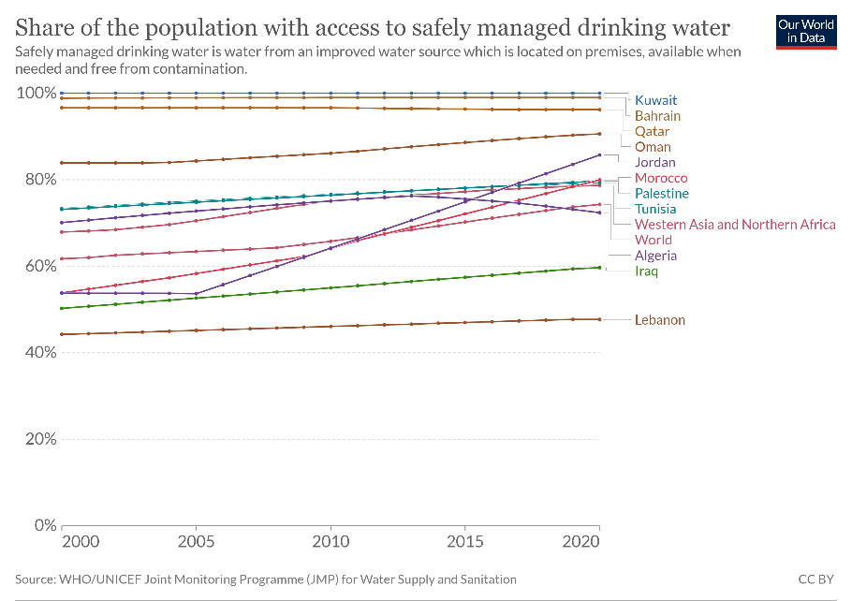

Figure : Share of The Population with Access to Safely Managed Drinking Water

As we can see in Figure 5: Share of The Population with Access to Safely Managed Drinking Water, the world has an average of about 70% of the whole population that has access to safety managed drinking water, and of course, there are a lot of Arab countries that are doing better than the average such as Kuwait, Bahrain, and Qatar that have an average of more than 80% of the population that has access to safely managed drinking water. However, on the other hand, there are some Arab countries that are doing worse than the average such as Algeria, Iraq, and Lebanon that have an average of less than 72% of the population that has access to safely managed drinking water. Therefore, we can conclude that Lebanon, despite having a lot of people who have access to an improved water source, most of them don’t have access to safely managed drinking water due to various reasons. Aside from that, apart from Algeria, we can see that most of the Arab countries are having some improvements regarding this issue in the past few decades, but there is always a room for more improvement.

### 4.2.5. Death rate from unsafe water sources from 1990 to 2019

In the main website of OurWorldInData, we have found another interesting chart that represents the number of deaths from unsafe water sources from 1990 to 2019 in the Arab countries per 100000 people, which is fair enough in order to do our comparison.

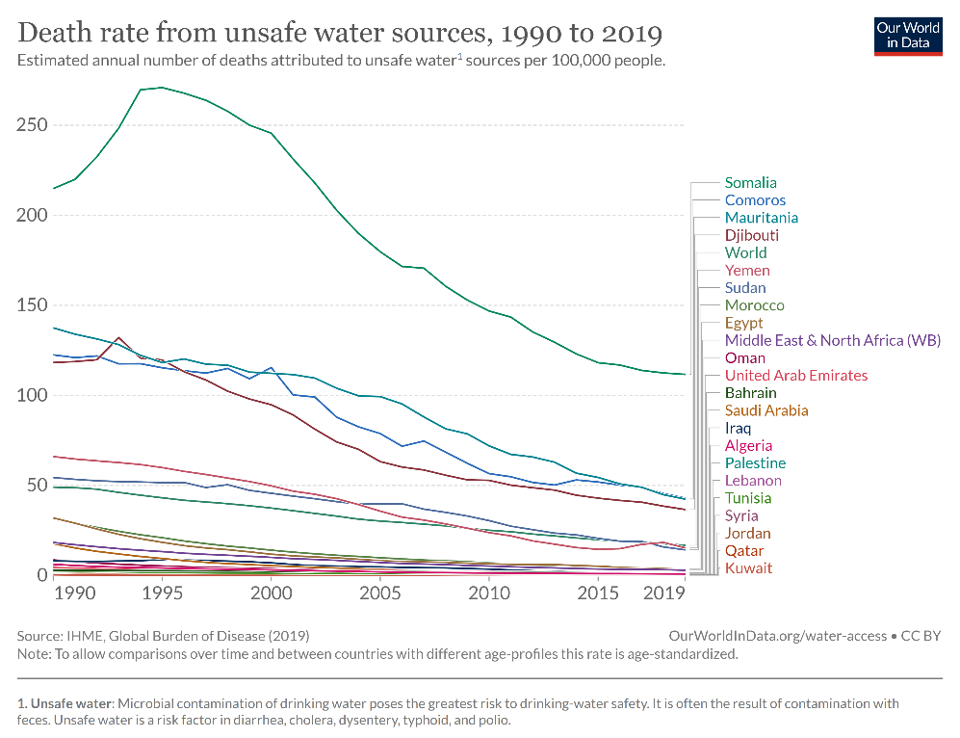

Figure : Death Rate from Unsafe Water Sources From 1990 to 2019

As we can see in Figure 6: Death Rate from Unsafe Water Sources From 1990 to 2019, this chart shows the number of deaths from unsafe water sources from 1990 to 2019 in the Arab countries per 100000 people. Speaking of which, there are a lot of Arab countries that are doing better than the world average such as Kuwait, Qatar, Jordan, along with many others that have less than 45 deaths per 100000 people with respect to the unsafe water sources, which is very good. However, on the other hand, there are few Arab countries that are doing worse than the world average such as Somalia, Comoros, Mauritania, and Djibouti, which have more than 45 deaths per 100000 people with respect to the unsafe water sources, which is bad and needs a lot of improvement. However, we can see that the majority of the Arab countries are improving in the past few decades in regards with the number of deaths from unsafe water sources, but there is always a room for more improvement.

### 4.2.6. Share of deaths attributed to unsafe water sources from 1990 to 2019

While in the same topic, in this section, we are more interested to show the percentage of deaths attributed to unsafe water sources in the Arab countries from 1990 to 2019.

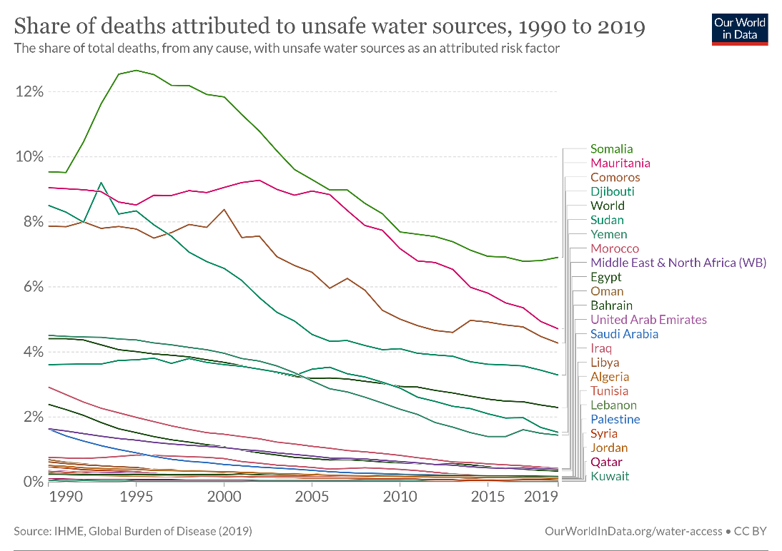

Figure : Share of Deaths Attributed to Unsafe Water Sources From 1990 to 2019

As we can see in Figure 7: Share of Deaths Attributed to Unsafe Water Sources From 1990 to 2019, this chart shows the percentage of deaths attributed to unsafe water sources in the Arab countries from 1990 to 2019. Speaking of which, there are a lot of Arab countries that are doing better than the world average regarding this topic such as Kuwait, Qatar, and Jordan, that have approximately 0% of the population that died from unsafe water sources, which is considered to be very good in general. However, on the other hand, there are few Arab countries that are doing worse than the world average such as Somalia, Mauritania, Comoros, and Djibouti, that have between 3% and 8% of the population that died from unsafe water sources, which is considered to be very bad, and there are a lot of decisions that need to be taken in these countries regarding this issue. Aside from that, mostly all of the Arab countries are improving in the past few decades regarding this issue, which is good, but there is always a room for more improvement.

### 4.2.7. Number of people without access to safe drinking water

In this section, we are going to represent a chart that represents the number of people without access to safe drinking water in some Arab countries from the year 2000 to 2020, and see whether we are making some improvements regarding this topic or not.

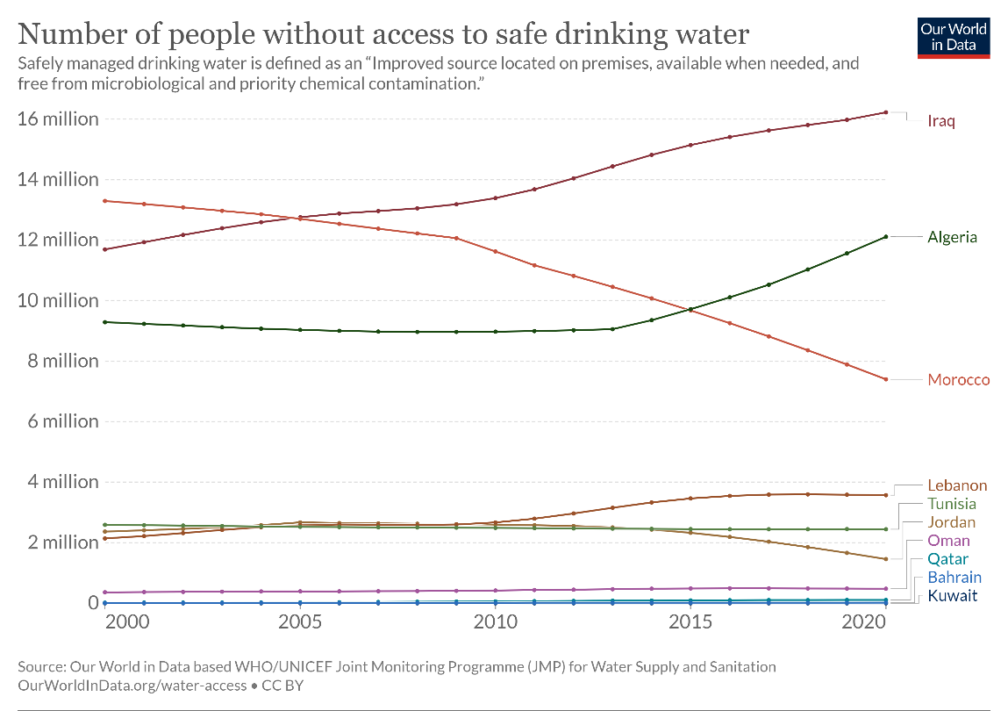

Figure : Number of People Without Access to Safe Drinking Water

As we can see in Figure 8: Number of People Without Access to Safe Drinking Water, this chart shows the number of people without access to safe drinking water in some Arab countries from the year 2000 to 2020. Speaking of which, there are a lot of Arab countries such as Kuwait, Bahrain, and Qatar, that have close to 0 people without access to safe drinking water which is very great. However, on the other hand, there are few Arab countries such as Iraq, Algeria, and Morocco, that have over 6 million people each without access to safe drinking water, which is a pretty high number, and there are a lot of decisions that need to be taken in order to make this number lower in these countries in the future. Aside from that, we can see that Algeria, Lebanon, and a lot of other Arab countries are facing some stagnation regarding this issue, which is very concerning and there are a lot of decisions that need to be taken in order to make the situation better in the future regarding this topic.

## 4.3. The main dataset

In order to develop the ETL pipeline, it is essential to gather some datasets regarding this topic. Speaking of which, using the UNICEF dataset, we were capable of gathering 1 main dataset and 6 other datasets that are excel files in order to do this task [19]. Besides that, it is quite important to note that after extracting our datasets, it is essential to transform it into a usable format, and then loading it into a target destination in order to store and analyze our data. On top of that, in order to build a great ETL pipeline, we need to understand the content, the structure, and the quality of the data that we are currently working with, and having some datasets will definitely allow us to better understand the data structure, test and validate ETL processes, measure the data quality, monitor performance, along with many others.

First of all, speaking about our main dataset, we tried to gather information about all of the Arab countries that are currently part of the Arab league. Speaking of which, these countries are: Algeria, Bahrain, Comoros, Djibouti, Egypt, Iraq, Jordan, Kuwait, Lebanon, Libya, Mauritania, Morocco, Oman, Qatar, Saudi Arabia, Somalia, Sudan, Syria (also known as the Syrian Arab Republic), Tunisia, the United Arab Emirates, and Yemen. Next, we tried to gather information between the year 2013 and 2020. After that, we tried to put some indicators that we want to make our research based on. Speaking of which, our indicators include the proportion of population with a handwashing facility with soap and water available at home, a limited handwashing facility, and no handwashing facility at home, and the proportion of the population using at least basic sanitation services, basic sanitation services, on-site sanitation facilities with human waste disposed in situ and offsite, improved sanitation facilities, limited sanitation services, improved latrines and other improved facilities, sanitation facilities connected to septic tanks, and sanitation facilities connected to sewer networks. Moreover, it includes the proportion of the population using safely managed sanitation services, sanitation facilities connected to sewer networks and with sewage treated to at least secondary levels, at least basic drinking water services, improved drinking water sources available when needed, basic drinking water services, improved drinking water sources, limited drinking water services, non-piped improved drinking water sources, piped drinking water sources, improved drinking water sources located on premises, improved drinking water sources free from fecal and priority chemical contamination, safely managed drinking water services, surface water, and unimproved drinking water sources. Lastly, it includes the proportion of schools with basic hygiene services, with basic sanitation services, with limited sanitation services, with no sanitation service, with basic drinking water services, with limited drinking water services, and with no drinking water service. Aside from that, it is essential to note that all of these proportions are mainly displayed as percentages out of 100. However, while opening the dataset using the following link: <https://docs.google.com/spreadsheets/d/1O83V3lxbnfMQGNHFmu-EZMl3r1pphxLb/edit?usp=sharing&ouid=105535614615338973847&rtpof=true&sd=true> , we can see clearly that there are some values that are displayed as ‘-‘, and this symbol means that there is no data related to that indicator in a particular country in that year. Therefore, this is considered to be dirty data, and we need to handle it.

## 4.4. Other datasets

While searching in the main website of UNICEF, we have found several other important datasets regarding this topic [20]. Speaking of which, there are two datasets that represent some estimations on the use of water, sanitation, and hygiene per country and per region. There are also two datasets that represent some estimations on water, sanitation, hygiene, waste management, and environmental cleaning in health-care facilities by country and by region. And finally, there are 2 datasets that represent some estimations on water, sanitation, and hygiene in schools by country and by region. Moreover, in order to access these datasets, kindly follow the links in the references down below [20]. Aside from that, it is essential to note that all of these proportions are mainly displayed as percentages out of 100. However, while opening these datasets, we can see clearly that there are some values that are displayed as ‘- ‘, and this symbol means that there is no data related to that indicator in a particular country in that year. On top of that, we can see that all of the countries and the regions in the world are represented in these datasets, thus, we need to filter the data to see only the main data that is related to the Arab countries. Besides that, the datasets related to health-care and schools were only made in 2021, and the two datasets that represent some estimations on the use of water, sanitation, and hygiene per country and per region were mainly conducted between 2015 and 2020. Furthermore, it is essential to note that all of these datasets have several sheets in order to separate the indicators which is good.

Aside from that, as you will see in the next section that is related to the ETL pipeline, we decided to merge these six datasets into 1 mega database.

# V. Implementation

## 5.1. System’s requirements

To use the Water-Scarcity Risk Evaluation System, users need a computer or laptop running Windows 10 operating system with a minimum of 2GB RAM. The application is optimized for 64-bit systems to ensure optimal performance. Additionally, users are required to have access to the necessary datasets, which should be imported into Google Drive. To interact with the provided code and execute the analysis, users are expected to have a Google Colab account. Furthermore, Python must be installed on the user's machine, allowing seamless execution of the code and analysis within the Google Colab environment [21].

### 5.1.1. Minimum Hardware Requirements:

* Computer or laptop with Windows 10
* 2GB of RAM
* 64-bit architecture

### 5.1.2. Software Requirements:

* Access to necessary datasets imported into Google Drive
* Google Colab account for code execution and analysis
* Python installed on the user's machine

## 5.2. Code of merging datasets

Speaking about the ETL, we successfully managed to extract our data from a trusted resource. Therefore, we have completed the first step of ETL. However, there are two steps left which are transformation and loading. Speaking of which, using google collab, we managed to create a file called ‘Research work’ which could be found in this link: <https://colab.research.google.com/drive/1dksNRU-2am_UtMIOECmBRFr16h8Pnu-6?usp=sharing>. Speaking of which, we firstly imported our required libraries, and then, with the help of google drive, we were able of importing our seven datasets successfully. After that, we decided to check whether there is dirty data in them, and it turned out that the only dirty data that could impact our analysis is the presence of the “- “symbol, which as discussed above, means that there is no data related to that indicator in a particular country in that year. However, since we don’t know exactly the main values of these symbols, we decided to handle this dirty data by simply leaving it as it is. After that, we decided to start merging our data by firstly merge the two datasets that represent some estimations on the use of water, sanitation, and hygiene per country and per region into a new merged dataset called “general data -merged.xlsx”, which was mainly done by merging the three sheets that represent the water, the sanitation, and the hygiene in both of these datasets to represent both the datasets per country and per region in the same sheet. Speaking of which, as an example, the water sheet in the first dataset that represents the data per country and the water sheet in the second dataset that represents the data per region were merged into one sheet called water that represents both the data per country and per region, and the same thing was done for the other two sheets. Next, we decided to merge the two datasets that represent some estimations on water, sanitation, hygiene, waste management, and environmental cleaning in health-care facilities by country and by region into a new merged dataset called “health care facilities -merged.xlsx”, which was mainly done by merging the five sheets that represent the water, the sanitation, the hygiene, the waste management, and the environmental cleaning in both of these datasets to represent both the datasets per country and per region in the same sheet. Speaking of which, as an example, the water sheet in the first dataset that represents the data per country and the water sheet in the second dataset that represents the data per region were merged into one sheet called water that represents both the data per country and per region, and the same thing was done for the other four sheets. After that, we decided to merge the two datasets that represent some estimations on water, sanitation, and hygiene in schools by country and by region into a new merged dataset called “merged_school_data.xlsx”, which was done by simply adding the one sheet of the first dataset and the three sheets of the second dataset, and load them into a new spreadsheet which consists of four sheets. After that, we managed to upload these three new merged datasets into google drive, and then, we decided to merge these three merged datasets into one mega dataset called “merged_data.xlsx”, which was done by simply adding the three sheets of the first merged dataset and the five sheets of the second dataset, and the four sheets of the third dataset, and load them into a new spreadsheet which consists of twelve sheets, and we managed to upload it to google drive as well, which could be found in this link: <https://docs.google.com/spreadsheets/d/12F2YGkzgFDjN26f5bedBKWhcQnqn5o41/edit?usp=sharing&ouid=105535614615338973847&rtpof=true&sd=true>.

## 5.3. Selected tools for developing our water-scarcity risk evaluation system

The development of the Water-Scarcity Risk Evaluation System MVP involved a thoughtful selection of tools to ensure efficiency, flexibility, and scalability [22]. The following tools were chosen for various aspects of the development process:

1. **Programming Language: Python**

* Python was selected for its versatility, extensive libraries, and data analysis capabilities. It serves as the primary language for data manipulation, statistical modeling, and machine learning.

1. **Data Analysis and Visualization: Pandas and Seaborn**

* Pandas, a powerful data manipulation library, was used for cleaning and processing datasets. Seaborn was employed for creating insightful visualizations to communicate complex data trends effectively.

1. **Machine Learning: Scikit-learn (sklearn)**

* Scikit-learn was utilized for implementing linear regression models, facilitating predictive analysis of water availability in the Arab world.

1. **Notebook Environment: Google Colab**

* Google Colab, a cloud-based Jupyter notebook environment, was chosen for its collaborative features, access to GPU resources, and seamless integration with Google Drive for dataset management.

1. **Linear Regression: Scikit-learn (sklearn)**

* Scikit-learn's implementation of linear regression models enabled the prediction of future water availability based on historical data.

These selected tools collectively contribute to the development and functionality of the Water-Scarcity Risk Evaluation System MVP, offering a robust foundation for ongoing enhancements and iterations.

## 5.4. Code of water-scarcity risk evaluation system

Speaking about the water risk assessment in the Arab world, we successfully managed to extract our data from a trusted resource and imported them in google drive. After that, using Google Colab, we managed to create a file called “Water Scarcity Risk Assessment in The Arab World.ipynb” which could be found in this link: <https://colab.research.google.com/drive/1cjWLphO8BpU0OVFxlQogq7xN9WCYCL-U?usp=sharing>. Speaking of which, we firstly imported our required libraries, and then, with the help of google drive, we were able of importing our six datasets successfully. After that, we decided to split our work by importing each sheet of these datasets individually. After that, we decided to do some functions in order to filter the countries in these datasets to return only the data that is related to the Arab countries. Then, we decided to use matplotib and seaborn frameworks in order to display a chart about the current water availability in each Arab country. After that, using Scikit-learn (also known as sklearn), we managed to assess the water scarcity risk in the Arab countries in the future. Speaking of which, we based our research on representing charts according to each country’s national level, along with representing charts according to each country’s rural areas and urban areas, which would have a significant role of helping the main stakeholders to make their decisions regarding this issue in a more accurate way by considering all of these factors. However, speaking about the charts that we decided to represent, here is a list of all of them:

* Future Projection of Water Availability in The Arab World (National)
* Future Projection of Water Availability in The Arab World (Rural)
* Future Projection of Water Availability in The Arab World (Urban)
* Future Projection of Sanitation Availability in The Arab World (National)
* Future Projection of Sanitation Availability in The Arab World (Rural)
* Future Projection of Sanitation Availability in The Arab World (Urban)
* Future Projection of Basic Water Services in the Arab World (National)
* Future Projection of Basic Water Services in the Arab World (Rural)
* Future Projection of Basic Water Services in the Arab World (Urban)
* Future Projection of Basic Sanitation Services in the Arab World (National)
* Future Projection of Basic Sanitation Services in the Arab World (Rural)
* Future Projection of Basic Sanitation Services in the Arab World (Urban)
* Future Projection of Basic Hygiene Services in the Arab World (National)
* Future Projection of Basic Hygiene Services in the Arab World (Rural)
* Future Projection of Basic Hygiene Services in the Arab World (Urban)
* Future Projection of Basic Waste Management Services in the Arab World (National)
* Future Projection of Basic Environmental Cleaning Services in the Arab World (National)
* Future Projection of Basic Water Services in Schools in the Arab World (National)
* Future Projection of Basic Water Services in Schools in the Arab World (Rural)
* Future Projection of Basic Water Services in Schools in the Arab World (Urban)

After that, we decided to display some charts that are related to the availability of clean water by country, the unimproved water index by country, the availability of limited water by country, the availability of surface water by country, and the annual rate of change by country. Speaking of which, we decided to represent each of these charts in a different color in order to differentiate them. Moreover, we have successfully presented these charts by defining two weights that represent the rural areas and the urban areas respectively, and we combined them and drew our charts accordingly.

Now let me show you some of these charts. However, in order to see all of them, kindly click on the Google Colab link provided above:

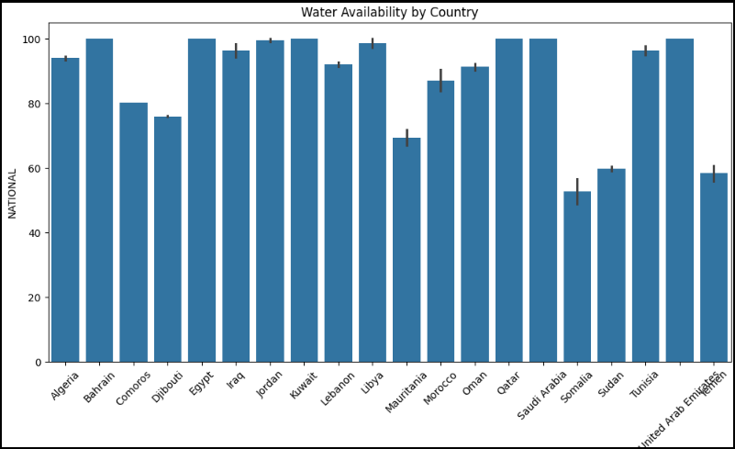

Figure : Current water availability by country

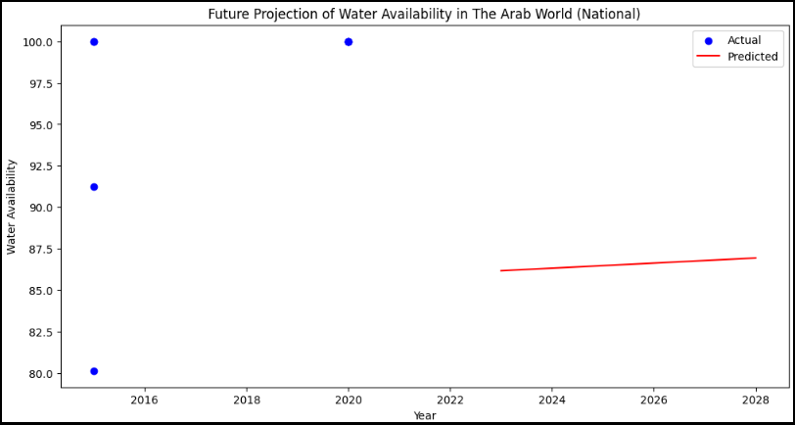

Figure : Future Projection of water availability in the Arab World (National)

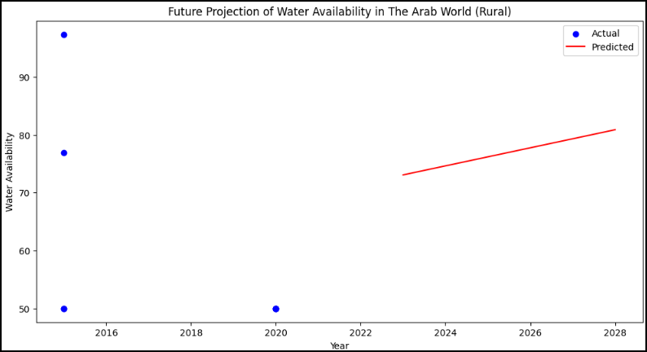

Figure : Future Projection of Water Availability in The Arab World (Rural)

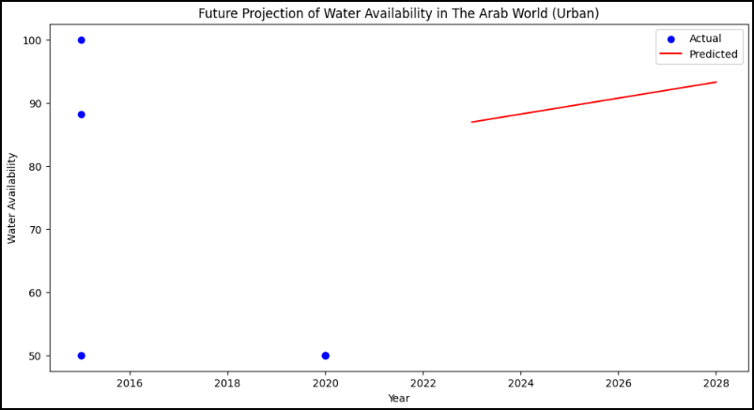

Figure : Future Projection of Water Availability in the Arab World (Urban)

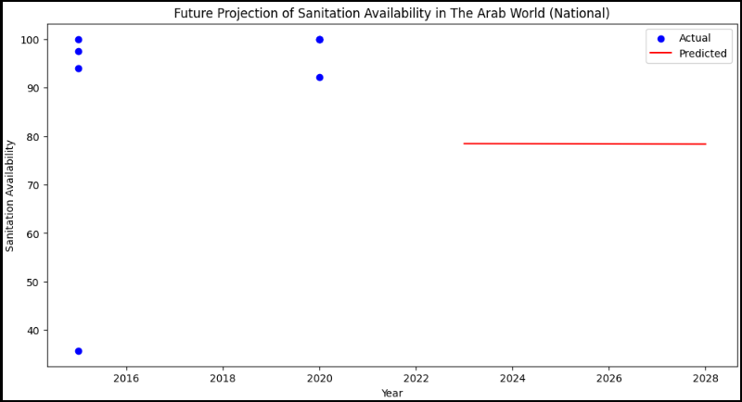

Figure : Future Projection of Sanitation Availability in the Arab World (National)

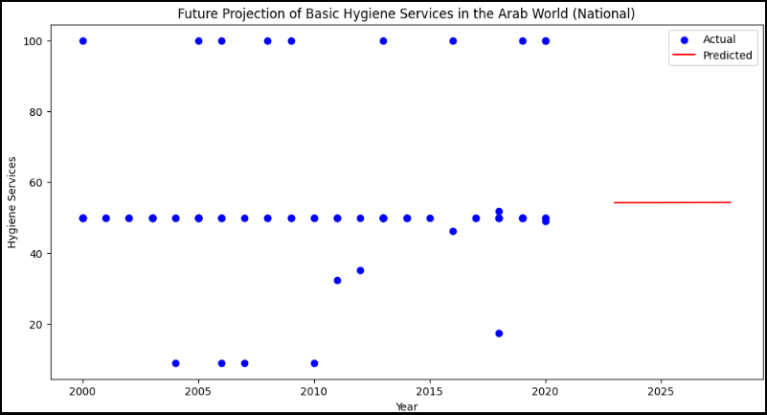

Figure : Future Projection of Basic Hygiene Services in the Arab World (National)

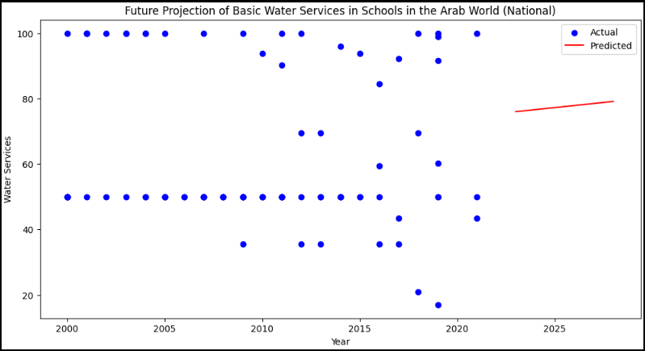

Figure : Future Projection of Basic Water Services in Schools in the Arab World (National)

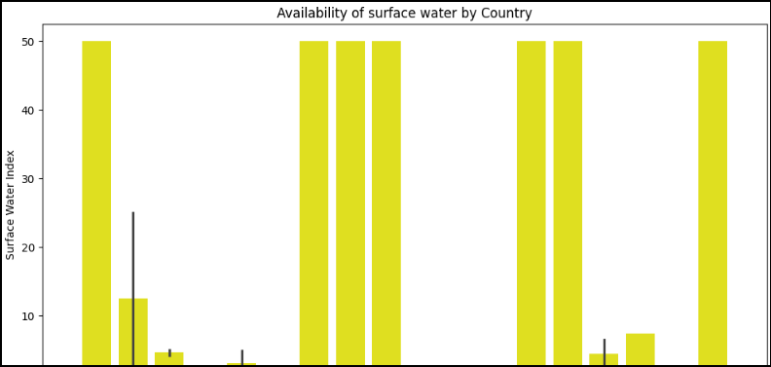

Figure : Availability of Surface Water by Country

## 5.5. Conclusion

After drawing these charts using Google Colab, all the main stakeholders can benefit from them by analyzing them and making decisions that could benefit their countries in order to limit the water scarcity risk in the future. On top of that, drawing these charts has a huge role of helping us to manage our project in a profound way so that we can see the broad picture of our project.

# VI. References

Considering the references, we put some numbers surrounded by square brackets in our report, in order to allow the teacher to know that the provided information was brought using Google. Thus, we decided to provide all the references to these pieces of information here using “Harvard” style.

1. World Wildlife Fund (2022). *Water Scarcity | Threats | WWF*. [online] World Wildlife Fund. Available at: https://www.worldwildlife.org/threats/water-scarcity [Accessed 10 Apr. 2024].
2. UNICEF (2020). *Water scarcity*. [online] www.unicef.org. Available at: https://www.unicef.org/wash/water-scarcity#:~:text=Half%20of%20the%20world [Accessed 10 Apr. 2024].
3. Enzo (2023). *The Definitive Guide to Building a Predictive Model in Python*. [online] Graph Database & Analytics. Available at: https://neo4j.com/blog/build-predictive-model-python/ [Accessed 10 Apr. 2024].
4. GIS Geography. (2020). *10 Python Libraries for GIS and Mapping*. [online] Available at: https://gisgeography.com/python-libraries-gis-mapping/ [Accessed 10 Apr. 2024].
5. Chien, C. (2020). *How do you identify and manage risks in software development?* [online] Codebots. Available at: https://codebots.com/way-of-working/how-do-you-identify-and-manage-risks-in-software-development [Accessed 10 Apr. 2024].
6. Wrike. (2023). *What is Iterative and Incremental Development?* [online] Available at: https://www.wrike.com/project-management-guide/faq/what-is-iterative-incremental-development/ [Accessed 10 Apr. 2024].
7. Awati, R. (2024). *What is iterative development? - Definition from WhatIs.com*. [online] SearchSoftwareQuality. Available at: https://www.techtarget.com/searchsoftwarequality/definition/iterative-development#:~:text=Iterative%20development%20is%20a%20way [Accessed 10 Apr. 2024].
8. Zoe. (2022). *Project Schedule Management [10 Reasons why it’s important]*. [online] Available at: https://zoetalentsolutions.com/project-schedule-management/ [Accessed 10 Apr. 2024].
9. Pubrica Academy (2019). *Why is it important to do a literature review in research?* [online] Pubrica. Available at: https://pubrica.com/academy/research/why-is-it-important-to-do-a-literature-review-in-research/ [Accessed 10 Apr. 2024].
10. mWater. (2021). *mWater*. [online] Available at: https://www.mwater.co/ [Accessed 10 Apr. 2024].
11. mWater. (2021). *mWater*. [online] Available at: https://www.mwater.co/ [Accessed 10 Apr. 2024].
12. Akvo Foundation. (2023). *Better data, bigger impact*. [online] Available at: https://akvo.org/ [Accessed 10 Apr. 2024].
13. Emeline, E. (2022). *Data is the new water*. [online] datajourney.akvo.org. Available at: https://datajourney.akvo.org/blog/data-is-the-new-water [Accessed 10 Apr. 2024].
14. www.openwaterdata.com. (2023). *Open Water Data*. [online] Available at: https://www.openwaterdata.com/ [Accessed 10 Apr. 2024].
15. Tobin, D. (2020). *The 6 Parts of ETL Data Pipeline Architecture*. [online] Integrate.io. Available at: https://www.integrate.io/blog/etl-architecture-building-blocks/ [Accessed 10 Apr. 2024].
16. www.drawio.com. (2023). *Blog - UML component diagrams show the structure of a system*. [online] Available at: https://www.drawio.com/blog/uml-component-diagrams [Accessed 10 Apr. 2024].
17. Fergusson, K. (2018). *Entity Relationship Diagrams with draw.io*. [online] draw.io. Available at: https://drawio-app.com/blog/entity-relationship-diagrams-with-draw-io/ [Accessed 10 Apr. 2024].
18. Ritchie, H. and Roser, M. (2019). *Clean Water Access*. [online] Our World in Data. Available at: https://ourworldindata.org/water-access [Accessed 10 Apr. 2024].
19. UNICEF (2021). *Drinking water - UNICEF DATA*. [online] UNICEF DATA. Available at: https://data.unicef.org/topic/water-and-sanitation/drinking-water/ [Accessed 10 Apr. 2024].
20. A. <https://docs.google.com/spreadsheets/d/1hk1VOr3rXemGffFs4nkyQb_sWFnJxbJY/edit?usp=sharing&ouid=105535614615338973847&rtpof=true&sd=true>

B. <https://docs.google.com/spreadsheets/d/12Qy4_DNBXJ44-Obq0eOTxDU2lHcoNWcw/edit?usp=sharing&ouid=105535614615338973847&rtpof=true&sd=true>

C. <https://docs.google.com/spreadsheets/d/1VipMcVb24phTtGRsynNPBLqZS3cs2cqt/edit?usp=sharing&ouid=105535614615338973847&rtpof=true&sd=true>

D. <https://docs.google.com/spreadsheets/d/1fc333G_uAjPfKeIoqbz7ihkqplnxdL37/edit?usp=sharing&ouid=105535614615338973847&rtpof=true&sd=true>

E. <https://docs.google.com/spreadsheets/d/16zTwGJAU2Np9Uuv9fx_Jy610xc5uu22a/edit?usp=sharing&ouid=105535614615338973847&rtpof=true&sd=true>

F. <https://docs.google.com/spreadsheets/d/1CHUpF7_a8WfAI9Qhc1T3YwrIqickaWxl/edit?usp=sharing&ouid=105535614615338973847&rtpof=true&sd=true>

1. Rouse, M. (2019). *What are System Requirements? - Definition from Techopedia*. [online] Techopedia.com. Available at: https://www.techopedia.com/definition/4371/system-requirements [Accessed 10 Apr. 2024].
2. seersco.com. (2022). *Why are Software Tools Important For Your Education? Here’s the Answer - Seers | Blogs*. [online] Available at: https://seersco.com/blogs/why-are-software-tools-important-for-your-education-heres-the-answer/ [Accessed 10 Apr. 2024].

**Words Count: 9176**